# Flowchart

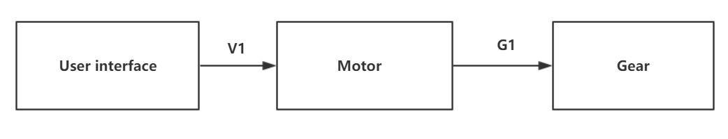

Figure 1 Motor component flowchart

# Table of limits

|  |  |  |  |  |
| --- | --- | --- | --- | --- |
| Interaction | Symbol | Min. | Max. | Unit |
| -> V1 | | | | |
| *Data from user interface sub-system (input block)* | | | | |
| Solar boat velocity | $$V$$ | 0 | 17 | Km/h |
| -> G1 | | | | |
| *Data to gearing calculation* | | | | |
| Motor torque output | $$T_{Motor-out}$$ | 0 | 3500 | Nm |
| Motor rotation speed ouput | $$ω_{Motor-out}$$ | 0 | 2200 | rpm |